MARINE GARBAGE ON THE BEACHES OF THE MUNICIPALITY OF PONTAL DO PARANÁ AND THE INTER-RELATIONSHIP WITH ARTISANAL FISHING ACTIVITY

Allan Paul Krelling1, 2, Celso Valerio Antunes@, 1

@*Corresponding author: celso.antunes@bol.com.br*

1*Postgraduate Program in Science, Technology and Society, Federal Institute of Paraná, Paranaguá, Paraná, Brazil*

two*Email: allan.krelling@ifpr.edu.br*

**SUMMARY**:

*The awareness and consequent concern for the sustainability of the environment has increased in recent times, as people are increasingly valuing the Earth's scarce natural resources. A problem of great current repercussion is related to marine litter, a complex cultural and multisectoral problem with significant implications for the marine and coastal environments of the world and for certain human activities. Marine litter is defined as any solid manufactured or processed waste that enters the marine environment from any source, including fishing. This economic activity makes use of work artifacts which, for the most part, are produced in polymeric resins (plastics) and other typologies. Considering that the nature of the artisanal fishing activity carried out by fishing communities crowded along the strip of beaches in the municipality of Pontal do Paraná, inserts them as one of the potential actors from the perspective of the generation of marine litter, the impact caused by this activity should be quantified in order to measure the magnitude of the problem. The present study seeks to determine the origins and abundance of marine litter along the strip of beaches in the municipality of Pontal do Paraná, having as a focus group the local fishing community.*

***Key words****:Environment. Artisanal fishing. Garbage at sea. plastics. Society/nature relationships.*

**ABSTRACT**:

Awareness and concern about the sustainability of the environment has increased in recent times as people are increasingly valuing Earth's scarce natural resources. A problem of great repercussion today is directed towards marine debris, which is a complex cultural and multisectoral problem with significant implications for the marine and coastal environments of the world and for certain human activities. Marine waste is defined as any solid manufactured or processed waste that enters the marine environment from any source, including fishing, which uses working artifacts mostly produced in polymeric resins (plastics) and other types. Considering that the nature of the artisanal fishing activity carried out by fishing communities along the strip of beaches in the municipality of Pontal do Paraná, place them as one of the potential actors from the perspective of the generation of marine waste, the impact caused by this activity should be quantified in order to measure the magnitude of the problem. The present study seeks to determine the origins and abundance of marine litter along the strip of beaches in the municipality of Pontal do Paraná, focusing on the local fishing communities.

**Keywords**:Environment. Artisanal fishing. Marine debris. Plastics. Society/nature relations.

1. INTRODUCTION

Awareness and consequent concern with sustainability have grown in recent times, as the Earth's natural resources have been increasingly valued. Knowledge about coastal ecosystems and the ability to use these environments are two key intrinsic values ​​affected by marine litter (NATIONAL RESEARCH COUNCIL, 2008). Globally, awareness of the diffusion and magnitude of marine litter and the environmental and social problems associated with it has been growing (RIBIC et al., 2012).

Marine litter is defined as any solid manufactured or processed waste that enters the marine environment from any source (COE; ROGERS, 1997). It is a complex cultural and multisectoral problem with significant implications for the world's marine and coastal environments and for certain human activities, which entails significant ecological, economic and social costs worldwide (NATIONAL OCEANIC AND ATMOSPHERIC ADMINISTRATION, 2012).

The problems caused by marine litter are multifaceted and essentially rooted in inadequate solid waste management practices. They are the result of product designs that do not consider life cycle impacts, consumer choices, accidental disposal or intentional dumping of fishing equipment, waste generated on ships, lack of waste management in coastal cities, infrastructure, garbage and the neglect of beach users about the possible consequences of their actions (NATIONAL OCEANIC AND ATMOSPHERIC ADMINISTRATION, 2012).

Marine litter can directly affect human health and safety in many ways, pose a potential hazard to navigation and threaten human safety by hitting vessels, necessitating rescues to its occupants (NATIONAL RESEARCH COUNCIL, 2008). It also poses a danger to swimmers and divers, who can become entangled in submerged debris (CHESHIRE et al., 2009).

Annual global demand for plastics has consistently increased in recent years and is currently around 245 million tonnes. As a versatile, lightweight, strong and potentially transparent material, plastics are ideal for a variety of applications. Their low cost, excellent oxygen/moisture barrier properties, bioinertia and light weight make them excellent packaging materials (DERRAIK, 2002). The fishing activity makes use of artifacts that, for the most part, are produced in polymeric resins (plastics) of the most varied typologies (eg Nylon® or polyamide, 100% polyethylene, fluorocarbon), as well as the technology involved in the application and use of these artifacts. .

In this way, the present work is justified by seeking an interrelation between the artisanal fishing activity developed by fishing communities located in the restinga area of ​​the municipality of Pontal do Paraná and the occurrence of marine litter in the sand strip adjacent to these communities, contributing to increase knowledge about the problem of marine litter and its different sources and related impacts.

For the purpose of this work, the focus group was chosen because: (i) it is inserted between the urban and marine environment of the edge of the oceanic platform south of Paraná; (ii) depend on an intact ecosystem to reap the fruits of their work and (iii) serve as a source of consultation for the design of environmental awareness programs with these communities.

2 MATERIALS AND METHODS

The fieldwork aimed to collect and analyze quantitatively and qualitatively (typology) the marine litter found near fishing communities on the beach strip between Pontal do Sul and Praia de Leste, in the municipality of Pontal do Paraná.

Marine litter assessments need to be planned to ensure they are within and across the context of a broader regional management framework (FIGURE 1) and are delivered consistently with the protocols.

FIGURE 1 - Stages in the development of a marine litter assessment

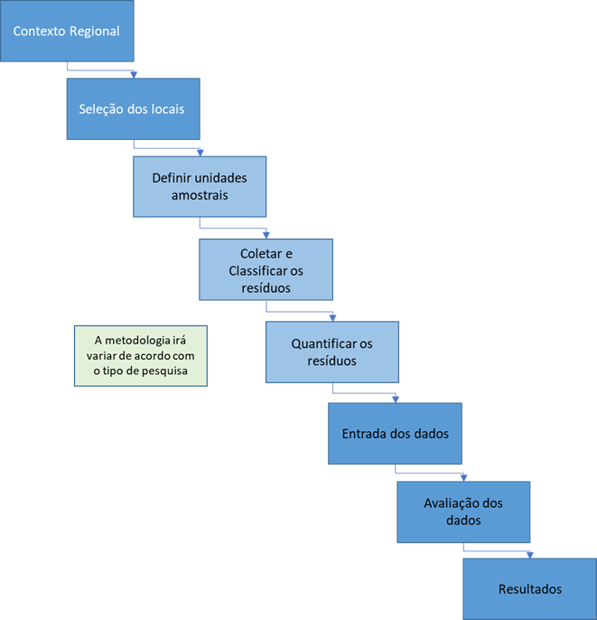

Source: Adapted from Guidelines on Survey and Monitoring of Marine Litter, UNEP, 2009.

In the following topics, the methodology adopted is described for the collection of residues found in the sand strips adjacent to the respective fishing communities.

2.1 Delimitation of the Study Area

The study area is located on the coastal strip of the municipality of Pontal do Paraná, where seven fishing communities are located. Of these communities, four were selected to carry out the collections (FIGURE 2). Initially, four fishing communities were selected within the scope area, namely: Canoas, Guarapari (point of “Control”), Shangri-Lá and Barrancos.

In order to facilitate the identification of the samples to be collected, these sectors were identified by letters, as can be seen (FIGURE 2) and in more detail (FIGURE 3) with the positioning of the quadrats along the sectors.

FIGURE 2 – Positioning of the sample sectors identified by the respective letters along the strip of beaches in the municipality of Pontal do Paraná. Being: “A” – Canoes, “B” – Guarapari (point of “Control”), “C” – Shangri-Lá and “D” – Barrancos.

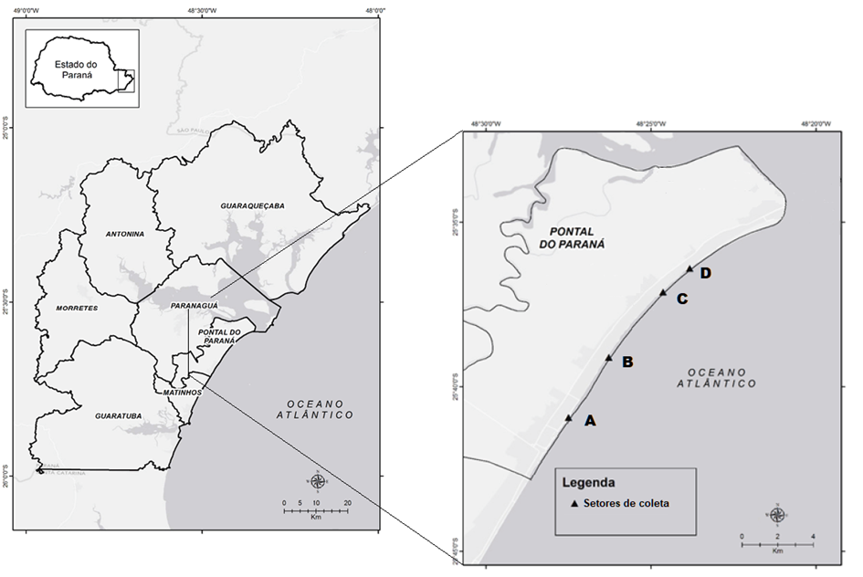

Source: Prepared by the author based on maps prepared by HUMBERTO ZONTINI MALHEIROS, 2014.

FIGURE 3 - Positioning of quadrats along points 1 to 10 in sectors A, B, C and D

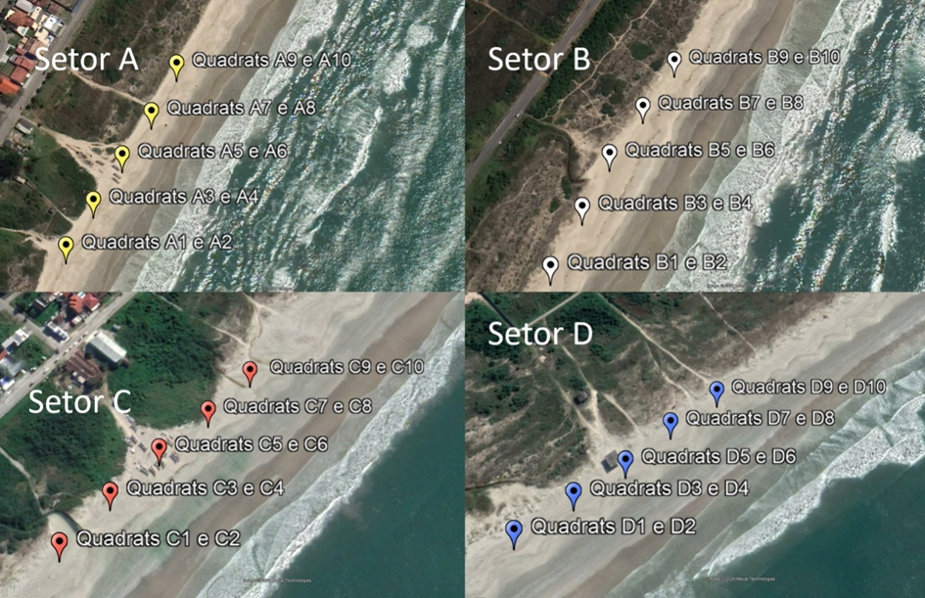

Source: AUTHOR, 2019.

The criterion adopted for the purpose of the study aimed at the choice of communities was based on the greatest possible equidistance between them, eliminating the colony of Ipanema, since it is very close to two other collection points (3,000 m). The Pontal do Sul colony was also suppressed due to the fact that it is located at the mouth of the Estuarine Complex of Paranaguá, suffering a different dynamics of currents and tides, in addition to being located at the mouth of a channel, factors that differentiate it from the others. other sectors, which may generate distortions in the analysis of results.

The adoption of a sector called “Control” is due to the fact that it is an isolated site, devoid of nearby fishing communities and, therefore, without direct interference from the possible impact of fishing activities carried out by a landing area of ​​a community of fishermen.

A first complete cleaning of the sand strip of each sector was carried out 100 meters equidistant from each side of the central point or exit to the sea of ​​the fishing community. This collection was carried out by collecting all the waste found and packing it in recycled plastic bags with a capacity of 100 liters.

2.2. Collection System

The collection system established 5 (five) points in each study area, positioned across the tide line and defined as follows: point called “Zero” positioned in front of the fishing community; point “1” positioned 100 meters to the right of point “Zero” (observer facing the sea); point “2” positioned 50 meters to the right of point “Zero” (observer facing the sea); point “3” coinciding with point “Zero”; point “4” positioned 50 meters to the left of point “Zero” (observer facing the sea) and point “5” positioned 100 meters to the left of point “Zero” (observer facing the sea). To ensure the correct distance between the points, a measuring tape with a length of 50 (fifty) meters was used.

For each collection point (from 1 to 5) two replies were collected (FIGURE 4), approximately 1 meter apart, totaling 10 samples per sector [eg: identification A1 = collection carried out in the “Canoas” sector positioned 100 meters to the right of the “Zero” point (observer facing the sea) and identification A2 = respective replica of the first collection carried out in the “Canoas” sector positioned 100 meters to the right of the “Zero” point (observer facing the sea); identification C3 = collection carried out in the "Shangri-Lá" sector positioned 50 meters to the right of the "Zero" point (observer facing the sea) and identification C4 = respective replica of the collection carried out in the "Shangri-Lá" sector positioned at 50 meters to the right of the “Zero” point (observer facing the sea)]. In addition to identifying the collection point and replica,

FIGURE 4 - Cross-sectional distribution scheme of collection points and replicas

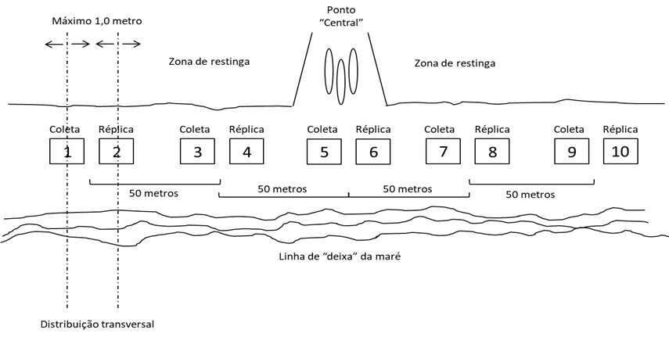

Source: AUTHOR, 2019.

Each sampling was performed in a 2m x 2m quadrat, totaling 4.0 m2 (four square meters). In order to facilitate the delimitation of this area, a device was built consisting of 4 (four) wooden sticks joined at one end by a cotton thread 8.0 meters long, forming a perfect square (FIGURE 5). This device, in addition to correctly delimiting the collection area, allows for easy displacement and quick assembly of the apparatus.

FIGURE 5 – Arrangement of the quadrat in the sand strip.

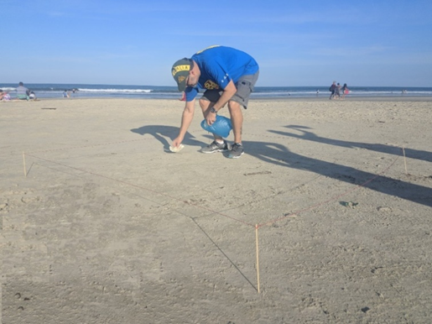

Source: AUTHOR, 2019.

The point for longitudinal positioning of each quadrat was randomly defined between the last “lead line” of the tide and the boundary line between the sand strip and the restinga area (FIGURE 6).

FIGURE 6 - Longitudinal positioning scheme for quadrats

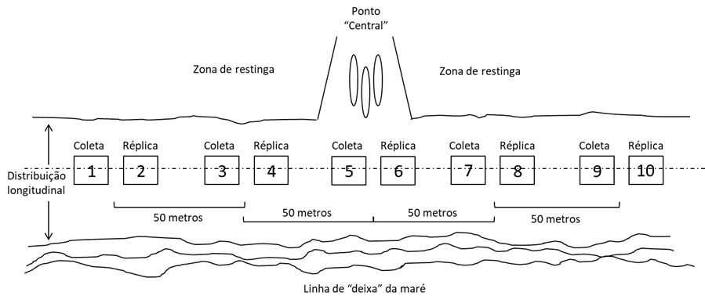

Source: AUTHOR, 2019.

Once the quadrat device was positioned, all residues found superficially inside it were collected, and this object could be of any nature, size and shape, as long as it is detectable with the naked eye. For packaging the materials, plastic bags measuring 20 cm x 35 cm were used, as can be seen in Figure 7. The plastic bags, once containing the collected waste, were closed with a tie and later identified with the letter referring to the sector, number referring to the point and the respective date and time of collection.

Then, they were placed in a plastic bag identified with the letter referring to the sector and with the respective start and end date and time of collection for later screening in the laboratory. The collections were carried out on the 21st and 22nd of June 2019 (collection 1); 06/29 and 30/2019 (collection 2); 06/07/2019 (collection 3); and 7/13 and 14/2019 (collection 4).

This temporal distribution occurred at intervals of one week and within a period of 30 days, at a time of year when there is no daily cleaning of the sand strip carried out by the city hall, which is carried out only between the months of December to February. This cleaning could de-characterize the accumulation at the collection points, with an impact on the result.

2.3. Screening and Characterization of Samples

In the Laboratory of Conservation & Management of the IFPR Campus Paranaguá, the sorting and characterization of the samples were carried out. The sorting and classification were carried out as follows: Each plastic bag, duly identified by the information “sector”, “point” and “date and time” of collection, was duly opened and the material contained in it was deposited in a plastic tray, as displayed (FIGURE 7).

Each residue present in the tray was then identified and characterized using a table containing a list of possible residues such as marine litter (TABLE 1, annex I).

FIGURE 7 - Preparation of samples for sorting and classification

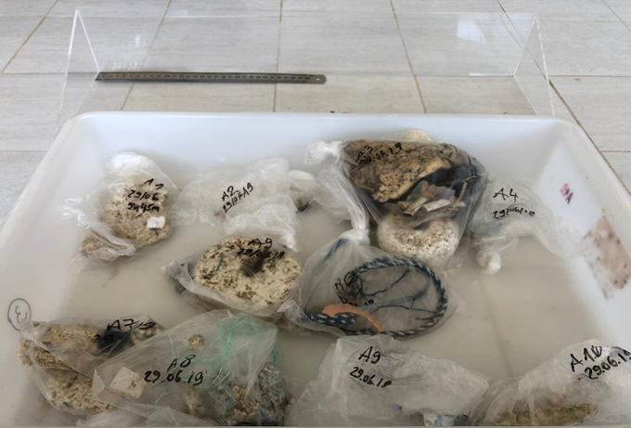

Source: AUTHOR, 2019.

2.4. Annotation Systematics

The appointment system in the worksheet was carried out according to the following criteria:

1.Waste composition;

2.Form of the residue;

3.Code referring to the combined composition and form;

4.Probable origin of the residue;

5.Others, this being a field used for additional information in order to improve identification.

Items 1, 2, and 3 follow an identification system based on the classification methodology of CHESHIRE et al. (2009), which was developed based on the alignment (whenever possible) of the garbage categorization tables of eight different research protocols. The resulting matrix comprised more than 220 types of marine litter and was further refined in order to consolidate categories considered similar, distributed by up to 10 classes and based mainly on the composition of marine litter (Annex I). Accordingly, nine typologies of marine litter were adopted. waste, identified as follows: BO – Rubber; MA – Woods; ME – Metals; Or others; PA – Papers; PL – Plastics; TE – Fabrics; VC – Styrofoam/Foam. In this job,

The system adopted establishes, as in the work of CHESHIRE et al (2009), two hierarchical levels that categorize items first by material composition (eg plastic, glass, rubber, etc.) and then by shape (eg bottles, foam, nets of fishing etc.). This leads to the differentiation between plastics (PL) and styrofoam/foam (VC), which are considered in the category of plastics, but the latter with specific applications in artifacts of fishing activity.

Additionally, items indicating fishing activity were identified (rope, fishing line, net and buoys) and used for analysis. This procedure was replicated for all samples related to all collection points in all sectors, according to the following categorization: Sector – beach where the collections were carried out (eg A, B, C and D); Point – location on the beach where the quadrat is arranged (eg in front of the community, points 5 and 6) and date of collection, thus making a total of 160 samples.

2.5. Statistical Method

Aiming at the unfolding of the analysis, four hypotheses were established, where the sequence adopted is not decisive and serves as a subsidy to corroborate the following theses:

I) if there is occurrence of marine litter with probable fishing origin in areas adjacent to fishing communities; II) whether there are differences between beaches with and without fishing communities, indicating in situ generation; III) whether there is a greater amount of marine litter of plastic composition in areas adjacent to fishing communities, in order to characterize the specific pollution caused by fishing activities; IV) if the occurrence of marine litter with probable fishing origin is more significant in the points located in the embarkation and disembarkation area of ​​the communities and less significant in the most distant places and V) if the density found in this work is different from that found in a scientific work with a similar sampling strategy.

• Hypothesis 1A: If the amount of solid waste found on beaches increases with the proximity of the source, then, it is expected to find a greater amount of items attributed to the probable fishing origin of the fishing communities crowded in the restinga area of ​​the municipality of Pontal do Paraná (large scale – in kilometers).

• Hypothesis 1B: Since it is expected to find a greater number of items indicating marine litter related to fishing (rope, fishing line, net and buoys) in areas adjacent to the crowded fishing communities in the restinga area of ​​the municipality of Pontal do Paraná, therefore, differences between beaches with and without fishing communities are expected (ie large scale “Control” – in kilometers).

• Hypothesis 2: If there is a dominance of plastics in marine litter, then it is expected to find a greater amount of marine litter of plastic composition in areas adjacent to the fishing communities crowded in the restinga area of ​​the municipality of Pontal do Paraná.

• Hypothesis 3: If the amount of solid waste found on beaches increases with proximity to the source, then it should be more significant at points located in the embarkation and disembarkation area of ​​the communities and less significant at more distant locations (small scale - in meters ).

• Hypothesis 4: The density found in this work is different from that found in the work by Widmer & Hennemann (2010).

Thus, for the tests of hypotheses 1A, 1B, 2 and 3, a non-parametric method known as the chi-square Kruskal-Wallis test was adopted. For hypothesis 4, the T-Test of comparison between means was adopted. The Kruskal-Wallis test (1952) results in the nonparametric equivalent of the one-sided parametric analysis of variance model (ANOVA).

An especially useful scenario of the Kruskal-Wallis test is when the responses are ordinal categorical data, where the normality assumption is almost never valid. (FAN et al., 2011). Since “n” means the number of points compared, this resulted in three degrees of freedom (n – 1 = GL, therefore, 4 – 1 = 3). This same logic was adopted for testing hypotheses 1B, 2 and 3. The analyzes were performed using the Action Stat program, version 3.6, to test these hypotheses.

Generalized Additive Models (MAG) were used to assess the association between marine litter items in relation to the distance (in meters) from the southern mouth of the Paranaguá Estuarine Complex (CEP). For this work, the MAG response variable is the count of marine litter items found on beaches. The candidate explanatory variable for the model was considered the distance from the mouth of the CEP. The MAG was used for this case, as it is common to observe non-linear explanatory patterns for studies related to litter at sea (BETTIM, 2017).

As a result, the MAG generates a smoothed curve that allows, in many situations, to describe the form of distribution of the response variable, revealing possible non-linear relationships (CONCEIÇÃO et al., 2001). The purpose of this analysis is not directly linked to the test of a specific hypothesis, but seeks to avoid confusion in the analyses. When evaluating the quantities of items in relation to the proximity of the mouth, we sought to exclude the influence of this proximity on the distribution of fishing items.

The MAGs used the following response variables: total items, items of undetermined origin; items originating from beach users, items of fishing origin and fishing indicator items (rope, fishing line, net and buoys). Although the last two seem similar, there are methodological differences in their identification. One is based on probable origin and the other is actually the format of the item found. Although a correlation was observed between the two variables (p-value<0.001), a low value was observed for the coefficient of determination (adjusted R2 = 0.43) and thus both were maintained to generate the MAGs. The MAGs were generated using the R software.

3 RESULTS

Throughout the sampling process, a total of 2196 items were collected in all sectors. Of these, 458 items were collected in sector “A” (Canoes), 524 items were collected in sector “B” (Control), 305 items were collected in sector “C” (Shangri-Lá) and 909 items were collected in sector “ D” (Barrancos). Of these, 1696 items were classified as plastics, 438 as styrofoam/foam, 12 as rubber, 2 as wood, 12 as metals, 16 as paper/cardboard, 12 as fabrics, 1 as construction material and 7 were classified as “other”.

FIGURE 8 presents the distribution of items found in the collections according to the categories established as their most likely sources versus the sampled sector, with graph I referring to the total of items found regardless of the category; Graph II being the items found with a fishing indicator; graphic III the items whose origin could not be determined and graphic IV the items found in the other categories.

FIGURE 8 – Quantitative distribution of the items found in the collections, within the categories established as the most likely sources, versus the sampled sector.

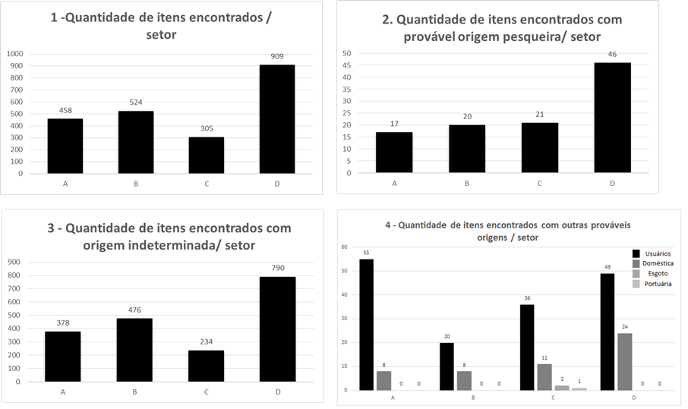

Source: AUTHOR, 2021.

Fishing indicative items (rope, fishing wire, net and buoys) totaled 104 items, representing 4.7(%) of all material collected in all sectors. Table 1 shows the distribution of items by sector, broken down by composition and most likely origin:

TABLE 1 - Distribution of items by sector and detailed by composition and most likely origin

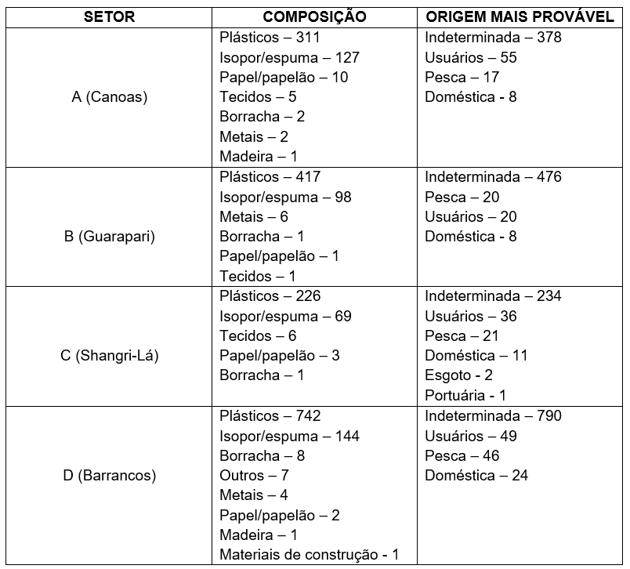

Source: AUTHOR, 2020.

Regarding marine litter items that had their origin most likely attributed to fishing (Hypothesis 1A), regardless of their format or type, no significant differences were observed in their quantities, according to the largest of the fishing communities.

Complementing the previous test, but now using only items with a format associated with fishing (rope, wire, net and buoy), significant differences were observed in their quantities (Hypothesis 1B), according to the largest of the fishing communities (TABLE 1).

TABLE 2 - Result of p-value via Kruskal-Wallis chi-square test for Hypotheses 1A and 1B

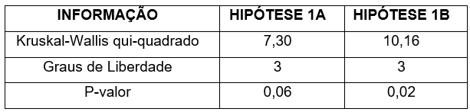

Source: AUTHOR, 2020.

Performing the post hoc tests, which generate table 3 of multiple comparisons – FWER (TABLE 3), no significant differences are observed in the comparisons between sectors (all p-values ​​greater than 0.05, significance level 95%). Although a difference between sectors was identified for hypothesis 1B, the post hoc tests failed to detect significant differences, as can be seen in table 4 of multiple comparisons - FWER (all p-values ​​greater than 0.05, significance level 95 %).

TABLE 3 - Multiple FWER comparisons between points and respective p-values ​​for Hypothesis 1A

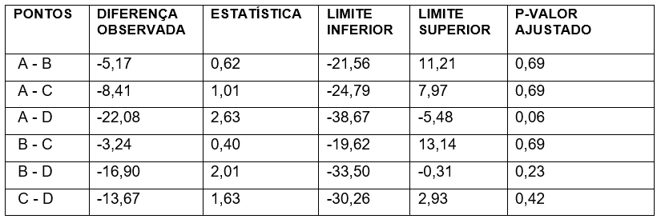

Source: AUTHOR, 2020.

TABLE 4 - Multiple FWER comparisons between points and respective p-values ​​for Hypothesis 1B

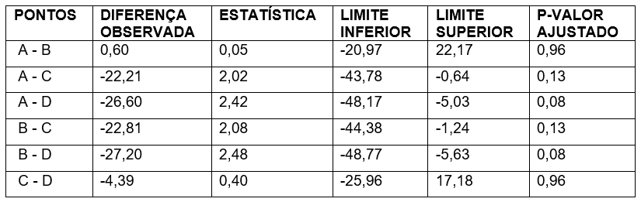

Source: AUTHOR, 2020.

The analysis of the difference between the main compositions of items found on the beaches indicated the dominance of plastics (p-value <0.001; Kruskal-Wallis chi-square=940.03; GL = 8). Corroborating the study's H3. Styrofoam and foam items (which are also plastic) formed the group with the second largest amount, distinguishing it from the rest of the other compositions (TABLE 5).

TABLE 5 - Table of groupings of averages related to waste typology

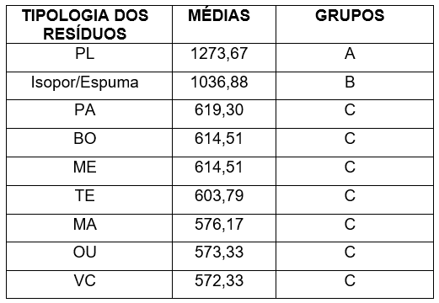

Source: AUTHOR, 2020.

For hypothesis 4, using as a reference the work carried out by Widmer & Hennemann (2010) on Santa Catarina Island, 10,226 items were collected in 10,000 m2 of beach area, resulting in a proportional value of 1.02 item/m2, while in this work, 2196 items were collected in 640 m2, reaching a proportional value of 3.43 items/m2. The other results of the respective test for hypothesis 4 are presented in TABLE 6 and Graph 1.

TABLE 6 - Results of the application of Student's "T" Test for Hypothesis 4

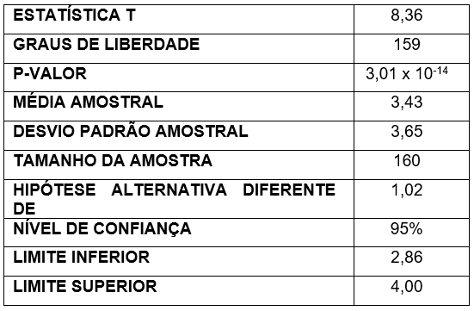

Source: AUTHOR, 2020.

FIGURE 9 - Distribution resulting from the application of Student's "T" Test for Hypothesis 4

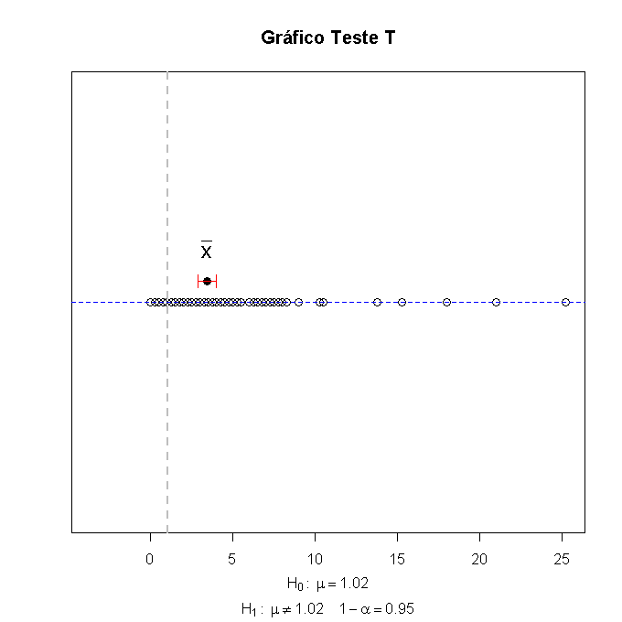

Source: AUTHOR, 2020.

Finally, the application of MAGs (FIGURE 10) indicates different behaviors for each origin. Items of undetermined origin and follow a distribution pattern similar to the distribution pattern when considering all the items observed in graphs 1 and 2 (FIGURE 10).

On the other hand, the items associated with fishing and the fishing indicator items (Graphs 3 and 4 of FIGURE 10) have a similar distribution, but different when compared to the distribution when considering all the observed items. Finally, the items that have beach users with the most likely origin (FIGURE 10).

FIGURE 10: Graphs relating the number of items found in the sectors by typology versus the distances of the sectors, in meters, in relation to the CEP

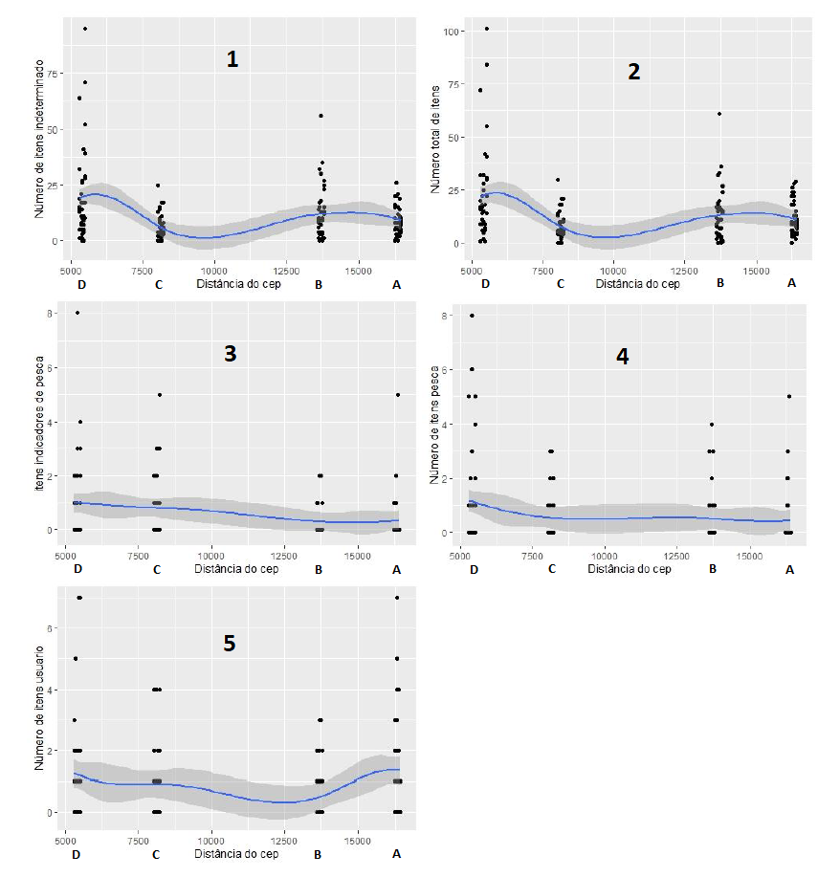

Source: AUTHOR, 2020.

4 DISCUSSION

For hypothesis 1A, in which the amount of solid waste found on beaches increases with the proximity of the fishing communities studied in the municipality of Pontal do Paraná, and considering a significance level of 5%, only marginal significance was observed (TABLE 2) which, when tested through multiple comparisons (post hoc - FWER), was not observed either. There were only marginal differences, therefore not significant, in the comparison between the communities of Canoas (A) and Barrancos (D) (TABLE 3). Hypothesis 1A was then refuted.

For Hypothesis 1B, in which it was expected to find a greater number of items indicating marine litter related to fishing (rope, fishing wire, net and buoys) between beaches with fishing communities and those without fishing communities, it was initially observed differences between sectors. That is, this result would indicate that at least one of the beaches would have a different amount of these items.

The expectation, to corroborate the initial hypothesis, would be to observe a smaller number of items in sector B (Guarapari) where there were no fishing communities. However, this did not happen when performing the post hoc analysis and no difference was detectable at a significance level of 95%. Through the analysis between sectors, the two comparisons that presented the lowest p-values ​​(in the order of 0.08) were related to the occurrence of a greater number of fish indicator items in sector “D”, Barrancos, which is one of the beaches with a fishing community., when compared to sectors A, (Canoes; with fishing community) and B (Guarapari; without fishing community).

As a consequence, hypothesis 1B was also refuted. Although not statistically significant, these results suggest the need for further analysis in the future that address the spatial aspect of the distribution of fishery indicator items, since the difference may be related to other factors in each sector, not evaluated in the present research.

Hypothesis 2 was statistically supported, being similar to several studies developed on a world scale that indicate that plastic is the main constituent of marine anthropogenic agents (BARNES et al., 2009; DERRAIK, 2002; POETA et al., 2014; SCHULZ et al., 2015; UNEP, 2009).

For Hypothesis 3, regarding the differences between the collection points in relation to the distance from the community (in meters), it was observed that the central quadrats, that is, the points located in the closest area of ​​embarkation and disembarkation of the communities, do not had higher amounts of fishing items (rope, fishing line, net and buoys) where p-value = 0.39; Kruskal-Wallis chi-square = 9.56; GL = 9. The same test was repeated, removing the control sector, and the same pattern was observed (p-value = 0.38; Kruskal-Wallis chi-square = 9.62; GL = 9).

Analyzing the distribution of residues along the sampled points, a concentration gradient that is decreasing from the entry point of the community and facing the sectors on both sides from the central quadrats (5 and 6) as initially imagined. Hypothesis 3 was refuted.

By visual observation during the sampling process, it was possible to verify a certain accumulation of residues in the access to the communities and adjacent to the restinga area. As this access is shared by the general population, it becomes difficult to attribute the occurrence of waste to a specific group (fishermen or beach users). To corroborate this observation, Slavin (et al., 2012) state that access points did not influence the levels of debris found in their work.

However, in another study, authors such as THIEL et al (2011) point out that part of the marine litter was found near ports, and this litter would come from navigation or fishing activities. This is a point that is not unanimous among the researches investigated and suggests that this relationship needs to be better investigated.

Throughout the sampling process, residues with probable fishing origin were visualized close to fishing vessels and facilities, however, in varying concentration from community to community, and quantitatively similar to other sampled points, where vessels or fishing facilities were absent. However, it is worth noting that a considerable amount of flotation equipment for fishing nets (ie buoys) was observed informally during the movement along the sand strip between the sectors.

It supports this observation, when analyzing that the curve generated in the GAM that relates items of fishing origin and items indicating fishing activity, presents greater stability, with a virtual absence of peaks along the beach profile analyzed in graphs 3 and 4 (FIGURE 10).). This pattern reinforces a pattern indicated by previous studies that suggest that these items observed on beaches can be attributed to different arrival processes, especially those of fishing origin, such as accidental disposal or intentional dumping of fishing equipment or the inadequate waste management in coastal cities (NATIONAL OCEANIC AND ATMOSPHERIC ADMINISTRATION, 2012).

The results presented reinforce this pattern, by indicating that the in situ generation process does not seem to have influenced the increase in residues of fishing origin, neither on small scales (in meters, in the analysis by quadrats) nor on large scales (in kilometers, in the analysis per community). As most of these residues are not identified as to their origin, it is also not possible to confirm that they were generated by the local fishing communities, which carry out their activities on the beaches of this municipality.

Additionally, using only items indicative of marine litter with probable fishing origin, that is, ropes, wire, net and buoys, still no differences were detected between the beaches. Even the beach considered “Control”, for not having a nearby fishing community, presented amounts of residue similar to the other beaches.

This finding reinforces what BARBOSA JR. et al. (2019) observed on beaches in Bahia, where the differences in the abundance of marine litter are not significant when comparing areas with and without the presence of communities. According to these authors, their expectations that there would be a greater abundance of marine litter in the coastal region close to human settlements were refuted, as observed in the present work.

Still according to the authors, two possible causes for this result would be: (I) garbage they call “exotic” (oceanic or distant origin) and (II) local community practices, since the municipality and small traders (crowded in stalls of beach), they clean stretches of beach close to places where summer equipment is made available to users.

In Sector "B" of the present work there are no fishing communities and it consists of an isolated beach strip, not equipped with infrastructure close to the beach and, consequently, presenting a low frequency of beach users. In this sector, the occurrence of marine litter with probable fishing origin was statistically similar to that found in the other sectors (A, C and D), these located in areas of fishing communities close to urbanized areas.

These results are similar to those of other scientific works, indicating that isolated and unpopulated islands and coastal strips accumulate as much debris as urbanized or populated areas and coastal islands SLAVIN et al (2012). This fact reinforces that the dispersion of marine litter with proven fishing origin on the beaches of the municipality of Pontal do Paraná occurs in a distributed, random way and impacts beaches regardless of their degree of population.

Regarding hypothesis 4, in this work a density of 3.43 items/m2 was found, while Widmer & Hennemann (2010) found a density of 1.02 item/m2, corroborating this hypothesis. Some factors may help to explain the spatial and temporal variations in the number of items found, such as the intervals between beach cleanings, carried out by NGOs or local authorities, which are not standardized and, therefore, the removal of garbage may vary over time HOELLEIN et al (2015), which may affect the results.

In the municipality of Pontal do Paraná, beach cleaning has been carried out since 2013 by the Sanepar concessionaire through personnel hired specifically for this purpose, who walk the sand strip on the edge of the municipality every day, performing manual collection. of waste in the morning and afternoon, aiming to ensure more comfort and health for bathers during the “official” summer season, which takes place between December and March (ANP, 2021). For the other months of the year this cleaning is interrupted.

Although there is a certain level of standardization in beach cleaning collections, whether in terms of daily frequency (intervals), individual and collective equipment, clothing, standard and safety procedures, in the other months of the year, the sand strips of beaches continue to receive marine litter without the consequent collection, providing new accumulation. Depending on the time of year in which the sampling of marine litter in the sand strip is carried out, the results may differ greatly and, for this work, we chose to collect the sample in a period between the summer seasons where beach cleaning could interfere with the quality of the data, both qualitatively and quantitatively.

Another factor that can influence the determination of the amount of marine litter collected in the sampling process would be the adoption of different methodological procedures for collection by the researchers. As an example, Widmer and Hennemann (2010) adopted collections through transects of different dimensions and the present work adopted the quadrat sampling technique. Sampling by transect allows a greater circumscription of residues - and consequently a greater spatial delimitation, which can result in greater sensitivity for detecting different concentrations of residues, in addition to the random characteristic normally adopted by researchers for the positioning of quadrats.

It is important to note that, even with methodological differences between the work by Widmer and Hennemann (2010), which uses the transect technique, and the present work, which uses the quadrat technique, we chose to compare these studies because they place It is located in the same compartment of the beach (the after-beach) in addition to the fact that in the literature correlates the occurrence of works with the same sample cutout is virtually non-existent.

Exemplifying the above, works such as the one by OIGMAN-PSZCZOL et al. (2007) adopted a collection procedure based on transects 4.0 m wide above the high tide mark and parallel to the coast. The length of these beaches ranged from 47 to 818 m. All visible debris found in each transect was identified in situ and recorded, resulting in an average total litter density of 13.76 items/100 m2.

Another work, by SYAKTI et al (2017), used quadrats measuring 2.0 by 2.0 meters along 30 m long transects, parallel to the coast. Sampling points were located 1 to 1.5 km from each other in a 40 km strip of beaches, resulting in an average total litter density of 8.3 items/m2. However, in this study, the focus was limited to the collection of plastic waste. RUIZ-OREJÓN et al (2016) found concentrations of items ranging from 0.009 to 1.16 items/100m2 on Mediterranean beaches, where sampling was performed in an “open” way along the beach strip.

Regardless of the type of methodological procedure adopted, the results obtained by this work, and linked to hypotheses 1A, 1B and 3, did not indicate statistically significant differences between the presence and absence of fishing communities, with regard to the generation of marine litter by these communities. In view of this finding, a question then emerges: what would be the probable origins of marine litter deposited on beaches?

Globally analyzing the graphs in Figure 10 resulting from the application of Generalized Additive Models (MAGs), it is possible to observe that there is a prevalence in relation to the number of items found, regardless of their origin, in points adjacent to sector D, which is closest to the mouth of the Estuarine Complex of Paranaguá (CEP), indicating that this is a possible source of waste on the beaches that make up the coastal strip of the municipality (sector D to sector A, in this sequence).

However, analyzing these graphs individually, it is possible to observe that graphs 1 and 2 indicate the influence of the outlet on the total quantity (and graph 2 reinforces this influence, since the items called "undefined" represent the large mass of items found). This dialogues with KRELLING et al (2017). In turn, Graphs 3 and 4 indicate that materials with probable fishing origins possibly suffer other influences on arrival at beaches in addition to the mouth, as the variation is smaller between the different points. This suggests a more uniform supply from the ocean, with a smaller influence of the inlet on the variation along the beach arc.

Graph 5 reinforces, due to the greater presence of items originating from users on beaches with more tourists, that the dynamics of entry of items is impacted by the presence of users. In this same figure, a slight increase can be observed in relation to items related to users in point “A”. This speaks to several literatures (SANTOS et al. 2004; SANTANA NETO et al. 2011; COE and ROGERS. 1997; RIBIC et al. 2012). Above all, the results bring something new, as they suggest that there is a different distribution for each source.

In this sense, this work highlights the importance of evaluating the different sources separately to understand the dynamics and flows (budgets) of items found. To justify this behavior, the analysis of graph 5 can be adopted regarding the increase in items related to beach users at points A and B. These points are located adjacent to the beach resorts of Praia de Leste (A) and Ipanema (B), and during the summer season it receives a considerable number of tourists and the resort of Ipanema becomes one of the busiest on the coast of Paraná (Portal da Cidade, 2019). Both have a fixed population quota throughout the year, comparatively higher than points C and D.

This curve behavior is not observed in graphs 3 and 4, which demonstrate items related to fishing activity, indicating that the garbage generated with probable origin in beach users is an important factor in the total composition of items found on beaches, considering the data from of the sampling carried out within the scope of this study. It is also possible to consider that the occurrence of waste from fisheries is evenly distributed along the entire stretch of beach, pointing to other factors in terms of probable origin, transport and disposal.

Regarding graph 3, which relates the number of items found with probable indication of fishing activity versus the distance to the CEP, as graph 4, which relates the number of items found with probable origin in fishing, a gradient can be observed decreasing number of occurrences from point D to point A, indicating that the proximity to the mouth of the CEP contributes to a greater deposition of items with probable fishing origin. There are more items in Balneário de Barrancos (sector “D”) in total items and items of undetermined origin. In the other sectors there is a decrease, due to their distance from the Estuarine Complex of Paranaguá (CEP; graphs 1 and 2),

In turn, graphs 3 and 4 represent, respectively, the distribution of fishing indicator items and total fishing items. As can be seen, there is still an indication of greater occurrence in sector “D”, however with a more uniform distribution throughout the four sampled sectors.

In view of these considerations, it is necessary to point out possible ways to explain the occurrence of fishing items on beaches, regardless of their exogenous or endogenous character. One of these paths is in line with the results of studies that observed that fishing lines produced in Nylon® monofilament are brought from adjacent underwater habitats to beaches due to storms (SMITH and MARKIC, 2013).

The results of the present work corroborate this statement based on the probable influence of the CEP as a vector of marine litter, assuming that this is the pattern that is reproduced in the beaches-objects of this study.

Considering the results of this work and the consonance with the investigated literature, the main vectors consist of natural phenomena, called natural vectors. In this way, all natural events that, despite not being elements that generate marine litter (but vehicles of it), and that contribute to this problem as non-human actants of the network, can be categorized as “Natural Vectors”.

The natural vectors, depending on the composition, size and buoyancy of marine litter, as well as ocean characteristics and other factors, can lead to the accumulation of marine litter at different depths of the ocean (WILLIAMS and RANGEL-BUITRAGO, 2019), forming an intermediate stock. over time and which can be returned to the beaches. Floating debris constitutes a fraction of the litter existing in the marine environment, which is transported by the wind and currents on the sea surface, being directly related to the “paths” taken by litter in the sea. Floating garbage can be transported by sea currents until they deposit on the sea floor, on the coast or degrade over time (JAMBECK et al., 2015).

Although the occurrence of anthropogenic debris items floating in the world's oceans was reported decades ago (VENRICK et al. 1972; MORRIS, 1980), the existence of floating marine debris accumulation zones in oceanic vortices (ie “islands”) it has only recently gained worldwide attention (MOORE et al., 2001). Other natural vectors such as Tsunami-type catastrophic events, such as the Great East Japan Earthquake, of magnitude 9.0 on the Richter scale, which hit the Japanese coast on March 11, 2011, resulted in the dumping of about 5 million tons. of debris, which is swept from land and coastal systems towards the ocean (Ministry of Environment, Japan, 2014).

The Government of Japan estimates that 70% of this debris sank close to the coast, leaving 1.5 million tons floating in the North Pacific Ocean with the potential to reach the coasts of North America (BAGULAYAN 2012; LEBRETON and BORRERO, 2013).

Geomorphological features such as slope, morphodynamic state of the beach and level of shelter (ARAÚJO and COSTA, 2007) can also influence the transport and accumulation regimes of marine litter. As can be seen, the generation of this residue is not attributed to the non-human actant "natural vectors", but it is understood that seas and oceans store the residue, which is anthropogenic, and this is later spread according to the various combinations of these " natural vectors”. This complexity of combinations still remains a field to be investigated.

CONCLUSIONS

The present work pointed out, based on statistical evidence, that the fishing communities that are the object of the study do not contribute to the increase in marine litter in situ. However, the presence of items of fishing origin in the marine litter found on these beaches suggests that this type of waste has priority anthropogenic generation ex situ and is brought to the beaches by natural vectors. In other words, it is a problem between and for the fishing communities.

Some gaps in this work can be pointed out, such as studying and understanding the nature and mechanism of generation of marine litter with probable origin in beach users, from the CEP to the limit of the municipality.

Another opportunity would be to study the quantitative and qualitative segmentation of marine litter with probable fishing origin, in order to identify what and how much is endogenous and exogenous to the scope of the study. It should be noted that items from different sources have different distribution dynamics in the beach environment, and further investigation is necessary. This work does not aim to exhaust the discussion about marine litter on beaches associated with fishing, whatever its modality and magnitude, however, it hopes to contribute towards expanding knowledge about the generation of marine litter in this important economic segment and economic activity, guaranteeing the sustainability of resources for future generations and environmental preservation.

REFERÊNCIAS

AGÊNCIA DE NOTÍCIAS DO PARANÁ (ANP). Curitiba, 2021. Disponível em: <http://www.aen.pr.gov.br/modules/noticias/article.php?storyid=110369&tit=Veranistas-geram-9-mais-lixo-nas-praias-do-Parana> Acesso em: 25 jan. 2021.

ARAÚJO, M.C.B.; COSTA, M.F. An analysis of the riverine contribution to the solid wastes contamination of an isolated beach at the Brazilian Northeast. Management of Environmental Quality an International Journal, 2007.

BAGULAYAN, A. et al. Journey to the center of the gyre: The fate of the Tohoku tsunami debris field. Oceanography, 25(2): 200–207. 2012.

BARBOSA JÚNIOR, E. C. *et al*. The influence of small human settlements on marine litter in the northeast coast of Brazil. Journal of Integrated Coastal Zone Management / Revista de Gestão Costeira Integrada 19(3):181-193. 2019.

BARNES, D.K.A. *et al*. Accumulation and fragmentation of plastic debris in global environments. Philos. Trans. R. Soc. B 364:1985–1998.

BETTIM, M. Influência de eventos meteorológicos e oceanográficos em pequena escala temporal da deposição de resíduos sólidos em praias de gradiente estuarino. 2017, 45 f: il.; 29 cm Dissertação (Mestrado em Sistemas Costeiros e Oceânicos, Centro de Estudos do Mar, Setor de Ciências da Terra) Universidade Federal do Paraná. Pontal do Paraná, 2017.

CHESHIRE, A. C. *et al*. UNEP/IOC Guidelines on Survey and Monitoring of Marine Litter. UNEP Regional Seas Intergovernmental Oceanographic Commission, 2009. (pp. XII + 120 pp.).

COE, J. M.; ROGERS, D. B. Marine debris: Sources, impacts and solutions (p. 432). New York: Springer, 1997.

CONCEIÇÃO, G. M. S.; SALDIVA, P. H. N.; SINGER, J. M. Modelos MLG e MAG para análise da associação entre poluição atmosférica e marcadores de morbi-mortalidade: uma introdução baseada em dados da cidade de São Paulo. Revista Brasileira de Epidemiologia, v. 4, n. 3, p. 206-219, 2001.

DERRAIK, J.G.B. ThePollution of the Marine Environment by PlasticDebris: a Review.Marine Pollution Bulletin 44: 842-852, 2002.

FAN, C., ZHANG, D., ZHANG, C. H. On sample size of the Kruskal-Wallis test with application to a mouse peritoneal cavity study. Biometrics 67:213–224. 2011.

HOELLEIN, T.J.; WESTHOVEN, M.; LYANDRES, O.; CROSS, J. Abundance and environmental drivers of anthropogenic litter on 5 Lake Michigan beaches: a study facilitated by citizen science data collection. J. Great Lakes Res. 41:78–86, 2015.

JAMBECK, J. R.; GEYER, R.; WILCOX, C.; SIEGLER, T. R.; PERRYMAN, M.; ANDRADY, A.; NARAYAN, R.; LAW, K. L. Plastic Waste Inputs From Land Into The Ocean. Science 13: Vol. 347, Issue 6223, pp. 768-771 DOI: 10.1126/science.1260352, Feb 2015.

Journal of Coastal Research, 26(6), 993–1000. West Palm Beach (Florida). ISSN 0749-0208, 2010.

KRELLING, A. P. Abordagem transfronteiriça do lixo marinho: A exportação de resíduos flutuantes ao longo de um gradiente estuarino e seus impactos socioeconômicos. 2017. 185 f. Tese (Doutorado em Sistemas Costeiros e Oceânicos, Centro de Estudos do Mar) - Universidade Federal do Paraná. Pontal do Paraná, 2017.

LEBRETON, L.M.; BORRERO, J.C. Modeling the transport and accumulation floating debris generated by the 11 March 2011 Tohoku tsunami. Marine Pollution Bulletin, 66(1): 53–58, 2013.

MINISTÉRIO DO MEIO AMBIENTE DO JAPÃO. A report on forecasts of tsunami driftage location. (http://www. antei.go.jp/jp/singi/kaiyou/hyouryuu/qanda_eng/gaiyou.pdf), 7 pp., Março de 2014.

MOORE, C.J.; MOORE, S.L.; LEECASTER, M.K.; WEISBERG, S.B.A Comparison of Plastic and Plankton in the North Pacific Central Gyre. Marine PollutionBulletin 42: 1297-1300, 2001.

MORRIS, J. R. Floating plastic debris in the Mediterranean. Marine Pollution Bulletin, 11, 125. (1980).

OIGMAN-PSZCZOL, S.S.; CREED, J.C. Quantification and classification of marine litter on beaches along Armação dos Búzios, Rio de Janeiro, Brazil. Journal of Coastal Research, 23(2), 421-428. West Palm Beach (Florida). ISSN 0749-0208, 2007.

POETA, G.; BATTISTI, C.; ACOSTA, A.T.R. Marine litter in Mediterranean sandy littorals: spatial distribution patterns along Central Italy coastal dunes. Mar. Pollut. Bull. 89: 168–173, 2014.

PORTAL DA CIDADE. Pontal do Paraná, 2019. Disponível em: <https://pontaldoparana.portaldacidade.com/noticias/turismo/pontal-do-parana-saiba-mais-sobre-as-praias-mais-visitadas-pelos-turistas-1242>. Acessoem: 25 jan. 2021.

RIBIC, C. A.; SHEAVLY, S. B.; RUGG, D. J.; ERDMANN, E. S. Trends in Marine Debris Along the U.S. Pacific Coast and Hawai’i 1998-2007. Marine Pollution Bulletin, 64(5): 994–1004. DOI: 10.1016/j.marpolbul.2012.02.008, 2012.

RUIZ-OREJÓN, L. F.; SARDÁ, R.; RAMIS-PUJOL, J. Floating plastic debris in the Central and Western Mediterranean Sea. Marine Environmental Research 120, 136–144, 2016.

SANTOS, I.R.; FRIEDRICH, A.C.; FILLMANN, G.; WALLNERKERSANACH, M.; SCHILLER, R.V.; COSTA, R. (2004). Geração de Resíduos Sólidos pelos Usuários da Praia do Cassino, Rs, Brasil. Revista de Gestão Costeira Integrada (ISSN: 1677-4841), 3:12-14.

SANTANA NETO, Sérgio P. de; SILVA, Iracema R.; CERQUEIRA, Maria B.; TINÔCO, Moacir S. Perfil sócio-econômico de usuários de praia e percepção sobre a poluição por lixo marinho: Praia do Porto da Barra, BA, Brasil. Revista de Gestão Costeira Integrada – Journal of Integrated Coastal Zone Management, vol. 11, núm. 2, 2011, pp. 197-206.

SCHULZ, M.; CLEMENS, T.; FÖRSTER, H.; HARDER, T.; FLEET, D.; GAUS, S.; GRAVE, C.; FLEGEL, I.; SCHREY, E.; HARTWIG, E. Statistical analyses of the results of 25 years of beach litter surveys on the south-eastern North Sea coast. Mar. Environ. Res. 109:21–27, 2015.

SLAVIN, C.; GRAGE, A.; CAMPBELL, M. L. Linking social drivers of marine debris with actual marine debris on beaches. Marine pollution bulletin. ISSN: 1879-3363, Aug; Vol. 64 (8), pp. 1580-8, 2012.

SMITH, S.D.A.; MARKIC, A. Estimates of marine debris accumulation on beaches are strongly affected by the temporal scale of sampling. PLoSOne 8, 8–13. doi:10.1371/journal.pone.0083694, 2013.

SYAKTI, A. D.; BOUHROUM, R.; HIDAYATI, N. V.; KOENAWAN, C. J.; BOULKAMH, A.; SULISTYO, I.; LEBARILLIER, S.; AKHLUS, S.; DOUMENQ, P.; WONG-WAH-CHUNG, P.Beach macro-litter monitoring and floating microplastic in a coastal area of Indonesia.Marine Pollution Bulletin. 122 217–25, 2017.

Tackling Marine Debris in the 21st Century. National Research Council. Washington, DC. The National Academies Press, 2008.

The Honolulu Strategy: A Global Framework for Prevention and Management of Marine Debris. U.S. Department of Commerce, National Oceanic and Atmospheric Administration, 2012. p. 50.

THIEL, M.; BRAVO, M.; HINOJOSA, I. A.; LUNA, G.; MIRANDA, L; NÚÑEZ, P.; PACHECO, A. S.; VÁSQUEZ, N. Resíduos sólidos antropogênicos no Pacífico SE: uma revisão do problema e soluções possíveis. RGCI - Revista de Gestão Costeira Integrada. Vol. 11,1 Ed, p115-134. 20p, 2011.

UNEP (2009). Guidelines on Survey and Monitoring of Marine Litter. p. 12.

VENRICK, E. L.; BACKMAN, T. W.; BARTRAM, W. C.; PLATT, C. J.; THORNHILL, M. S.; Yates, R. E. Man-made objects on the surface of the Central North Pacific Ocean. Nature, 241- 271. (1972).

WIDMER, W.M.; HENNEMANN, M.C. Marine Debris in the Island of Santa Catarina, South Brazil: Spatial Patterns, Composition, and Biological Aspects.

WILLIAMS, A.T. and RANGEL-BUITRAGO, N. Marine litter: Solutions for a major environmental problem. Journal of Coastal Research, 35(3), 648–663. Coconut Creek (Florida), ISSN 0749-0208. 2019.